## 

# 

PREPARING

**LESSON PLANS**

This job aid provides guidelines for planning each stage of a lesson, identifies appropriate teaching techniques to suit the lesson, and provides a sample lesson plan and template.

This job aid will help you to:

# support learning, based on an understanding of how people learn

# structure your lessons for deeper and richer learning

# What is a lesson?

A lesson is an organized set of activities designed to present one manageable-sized piece of your course. You may have more than one lesson in a 50-minute time block.

Do not confuse lesson with lecture (commonly used in course schedules). A lecture is just one teaching technique that you may use in a lesson.

# The stages and flow of a lesson

Each lesson should be a complete segment in itself, providing new learning. Keep your students in mind as you plan your lesson, considering:

* who they are
* what they already know
* why learning about this is useful for them
* what they must learn
* what they will do to learn
* how they will demonstrate their learning

What the instructor and students do varies at different stages of a lesson—beginning, middle, end—and relate to different elements of learning:*

* Beginning Attention and Motivation
* Middle Guidance and Practice (Participatory Learning)
* End Checking on Learning

Each stage should flow smoothly into the next, which builds on the previous. If students do not have an opportunity to go through all stages, learning may not occur!

* Descriptions of the elements of learning are adapted from *Principles of Instructional Design*, 1988 by Robert Gagne

# Guidelines for lesson planning

At different stages of the lesson, you need to pay attention to how we process information.

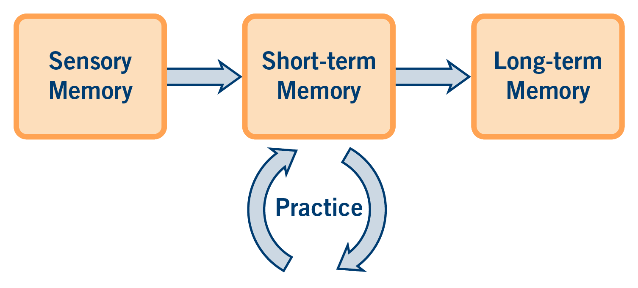

Three stages of learning

BCIT, 2022

## Beginning stage¾Stimulation, attention and motivation

Sensory memory: Sensory activities stimulate learners through their sensors (sight, sound, feeling).

As an instructor, part of your job is to get the attention of the students and motivate them—to help learners see the relevance and value of the new learning. Tell them what the learning outcome of the lesson is and how they can use it on the job and in their lives.

Ensuring that the lesson is at the correct level for learners is also important because this has an effect on motivation. Too easy can be boring and too difficult is often frustrating. Remember that learners can concentrate on only one thing at a time, so make sure they focus on what they need to learn.

The beginning of a lesson includes:

|  |  |
| --- | --- |
| **Bridge-in** | Draw the learners to the topic and capture their attention and interest. |
| **Outcome** | Identify what learners will be able to do by the end of the lesson. |
| **Pre-assessment** | Check on what learners already know or can already do to ensure that the lesson is at the right level. |

## Middle stage¾Guidance and practice (participatory learning)

Short-term memory: Learners hold information and learning in memory for a short time.

Long-term memory: Provide practice so that learning moves from short-term to long-term memory, where it can be stored for much longer periods of time.

The middle stage is where you spend most time teaching and where most of the learning happens. Through activities, instructional aids, student learning materials, and more, you can help students connect new information to something that they already know and help them remember it so that they can find it again later. People generally need a systematic way of organizing information in order to learn it. Make sure events and information are ordered logically so that learners can easily put it in long-term memory.

Another important part of your job is to provide opportunities for your students to use information or practice skills and to give your feedback and guidance. As an instructor, it is up to you to provide a variety of ways for your students to recall and practise new knowledge and skills.

The middle of a lesson includes **participatory learning**:

|  |  |
| --- | --- |
| **Guidance** | Use active learning activities that that allow students to investigate, build knowledge and skills, connect ideas, and receive guidance. |

|  |  |
| --- | --- |
| **Practice** | Use active learning activities that allow students to try things out for themselves and make further connections between ideas. More independent practice is often needed than can be completed in a lesson. Learners can continue to practise outside of class. |

## End stage¾Check learning and sum things up

The end stage is where you check if learning has occurred. It is important to gauge the level of learning, identify gaps or misunderstandings, and check what might be needed as review or follow up. It is equally important to help learners recognize their learning. This connects to learners’ motivation and feelings of self-efficacy and builds the ability to learn through reflection on their experiences.

The end of a lesson includes:

|  |  |
| --- | --- |
| **Post-assessment** | Check that outcomes were reached. This requires a way for learners to display learning so it can be reviewed. |
| **Summary** | Summarize learning and the lesson for clarity and as a review. Learning is further reinforced if learners do this high-level thinking. Instructors can also add value by sharing connections to the real world or upcoming lessons and ways to continue learning. |

# Using appropriate teaching and learning techniques

The techniques and tools you use in your lessons depend on:

* the types of students you have and their previous knowledge
* your teaching environment and the available equipment and resources
* the type of learning you are aiming for

Some possible teaching and learning techniques are listed below.

|  |  |  |
| --- | --- | --- |
| **To convey information** | **To balance presentation of a controversial subject** | **To involve people and connect learning to the real world** |
| * short presentations/ interviews * field trips * discussion groups * interviewing experts * selected reading, listening or video * case studies * demonstration by experts | * discussion groups * panel discussions * selected reading, listening or video * simulations * debates | * discussions * local news * field trips * case studies * role playing * group work * guided experience * interviews of industry guests |
| **To pool thoughts and ideas** | **To teach a skill** | **To reinforce memory** |
| * discussions * brainstorming * group work | * demonstrations * shop work * labs * guided experience * practice with feedback (coaching) | * drill or review * repeated experiences * memory aids * practice with feedback * exercises that connect ideas * writing (summarizing, explaining, drawing) |

Colleagues in your department may have additional suggestions well suited to your subject matter and students.

# Linking Lessons:

The next step in lesson planning is to consider how your lessons link together to achieve the course-level learning outcomes and even program goals or competencies. The BCIT LTC Lesson Plan template, found on the LTC website under Resources, will help you do this,. For more assistance, contact an IDC in the LTC

The following pages contain a template and sample helpful for planning lessons that you can adapt to your needs.

# Example Lesson Plan Template

|  |  |  |  |  |
| --- | --- | --- | --- | --- |
| Course |  | | | |
| Stage | Technique | Details | Resources | Time |
| Beginning | | | | |
| Bridge-in |  | Capture students’ interest and motivate them to learn. |  |  |
| Learning  Outcome(s) |  | Make the learning outcomes clear.  Connect learning to real life (show why and how they can use this). |  |  |
| Pre-assessment |  | Check level of background knowledge and experience |  |  |
| Middle | | | | |
| Participatory Learning |  | Review and build on related material.  Use a variety of media to illustrate concepts and processes.  Ensure that the lesson flows from simple to more complex.  Use strategies to actively involve students in the learning process  Provide opportunities for students to attempt the task and receive feedback |  |  |
| End | | | | |
| Post-assessment |  | Assess what students have learned, referring back to the intended learning outcomes. |  |  |
| Summary |  | Summarize the lesson.    Connect the lesson to real life and/or the next lesson.  Connect to program goals or competencies.  Suggest or provide additional opportunities for practice (homework, reading assignments, simulations, etc.) |  |  |
| Total Time | | | |  |

# Example 1 Hour Lesson Plan

|  |  |  |  |  |
| --- | --- | --- | --- | --- |
| **Course** | Instructional Skills Workshop | | | |
| **Stage** | **Technique** | **Details** | **Resources** | **Time** |
| **Beginning** | | | | |
| Bridge-in | Definition  Question | Show definition   |  | | --- | | **A learning outcome outlines the learning intention by identifying what the learner should be able to know, think, value, or do by the end of the lesson.**  Follow up: What is the value of having learning outcomes for a lesson? A course? | | Board or PPT or electronic whiteboard | 5 min |
| Learning  Outcome(s) | Explain & Inform | After reviewing learning outcome examples and identifying parts, learners will write a lesson outcome that includes condition, audience, behaviour, and degree (CABD). |  |
| Pre-assessment | Hands up | Please put your hand up if you:   * Know the parts of a lesson learning outcome * Have written a lesson learning outcome before * Feel confident you can write lesson learning outcomes * Write learning outcomes for all your lessons | Options: poll or survey using an online tool accessed via mobile |
| **Middle** | | | | |
| Participatory Learning | Presentation | Explain   * advantages of clearly defined outcomes * characteristics of lesson learning outcomes   + observable and measurable   + contain one verb   + for discrete unit of learning ~2–8 hours   + parts: condition, audience, behaviour, degree |  | 10 min |
|  | Discussion & Guidance | Give a few examples.  Learners identify parts (CABD) in list of outcomes. | List of outcomes | 15 min |
|  | Reading  Discussion | Hand out verb list.  Learners share questions/comments. | Verb list | 5 min |
|  | Practice  Feedback & Discussion | Thinking about a lesson they might possibly teach, learners write one outcome (with CABD) on a flip chart paper.  Learners review each other’s learning outcomes in small groups. | Flip chart paper and markers, tape | 10 min  10 min |
| **End** | | | | |
| Post-assessment |  | Ask participants   * What are the parts of LOs? * Did you write a complete LO? (with CABD) * What did you find easy/challenging? |  | 5 min |
| Summary |  | Solicit from learners:  What did you learn how to do?  Why is this important to you as an instructor?  How will you use what you learned? |  |
| Total Time | | | | 60 min |

2022 Learning and Teaching Centre at BCIT is licensed under a Creative Commons Attribution-Share Alike 4.0 International License.

3700 Willingdon Avenue, Burnaby BC V5G 3H2 • Tel (604) 432-8927 • F[ax (604) 431-7267 • http://www.bcit.ca/ltc](http://www.bcit.ca/ltc)